STUDENT ENROLEMENT FORM

Please Note: There are two parts to this training
- The Unit of Competency. You must be assessed as competent for the unit of competency before you can do the Department of Transport practical driving test.
- The Department of Transport practical driving test - this will enable you achieve the licence.

Unique Student Identifier (USI – www.usi.gov.au)
Esperance Training & Assessing can be prevented from issuing you a Statement of Attainment / Certificate of
Competency when you complete your course if you do not provide your Unique Student Identifier (USI)

Title | ❒ Mr  Ms  Mrs  Miss | Date of Birth
First Name |  | Middle Name
Surname |  | Drivers licence Number

Phone number |  | Email address

Postal Address
Suburb |  | Postcode
Residential
Address
('as above')
Suburb |  | Postcode

Referred by | ❒ Word of Mouth | ❒ Internet | ❒ Yellow pages | ❒ Other
Course | ❒ MC | ❒ HR | ❒ HC | ❒ EWP | ❒ FL
 | ❒ 1 day  2 days  Hourly lessons
Medical  Conditions | Students must present to Courses fit for duty as per normal workplace procedures. Any prescription medication must be brought with you for ETA, Trainers to confirm side effects, as per ETA Training Terms and Conditions.   I have medical conditions that requires medication and have informed ETA
Individual  Requirements | To customise your training, it is important that we are informed of any special considerations you may have regarding health, learning, language, literacy, numeracy, work hours or training and assessment arrangements. Please note below and discuss arrangements with your trainer.

Company Enrolments: Please note to enrol more students attach extra page/s to this form
Company name |  |  | Field
Company
Address
 | Suburb |  | Postcode
Contact name |  |  | Phone
E-mail address
Purchase order | Number |  | ABN

VET Provider Information  This information is compulsory. ETA  Trainers report this information to the  Training Accreditation Council | In which country were you born: _______________________  Do you speak a language other than English at home  Yes  No  Are you of Aboriginal or Torres Strait Islander origin  Yes  No  Do you consider yourself to have a Disability/Impairment  Yes  No If you indicated the presence of a disability, impairment or long-term condition, please select the area(s) in the following list:  (you may indicate more than one area) Please refer to the Disability supplement for an explanation of the following disabilities:  - Hearing/deaf (11)  - Physical (12) o Intellectual (13) o Learning (14) o Mental Illness (15)  - Acquired brain impairment (16) o Vision (17) o Medical condition (18) o Other (19)  What is your highest completed school level: Year 8 / 9 / 10 / 11 / 12 / NA  In which year did you complete that level: _____________  Have you successfully completed any of the following qualifications?  - Certificate I  Certificate II  Certificate III or Trade  Certificate IV  - Diploma  Adv Diploma or Assoc. Degree  Bachelor or Higher Degree  What is your current employment status:  - Full time  Part time  Self-employed  Employer  Employed- unpaid worker in family business  Unemployed – seeking work  Which best describes your reason for undertaking this study:  - To get a job  Develop existing business  Start own business  Different career  Gain a better job  Job requirement  Extra skills for my job  - Get into more study  Personal interest or self-development

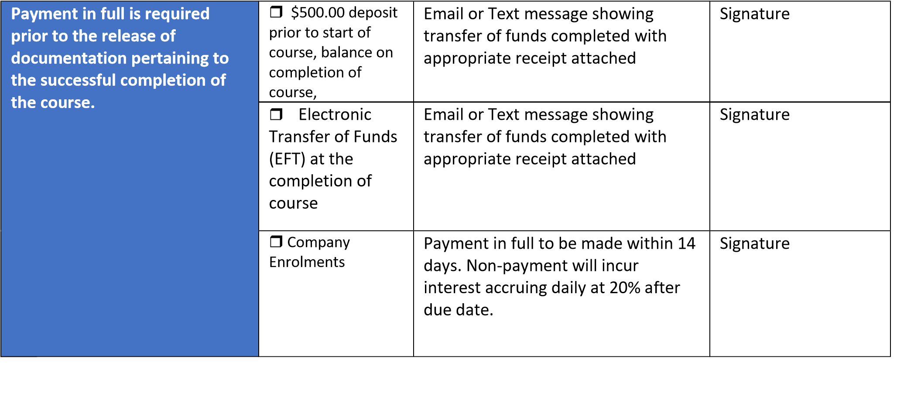

Training Agreement: Please read the ETA student handbook
I (name)_____________________________________________________________________________________ have received a copy of the ETA Student Handbook, have read and understood and agree to abide by ETA Trainer’s Training Conditions and Requirements.
Signature |  | Date

Privacy Notice

Under the Data Provision Requirements 2012 Esperance Training and Assessing is required to collect personal information about you and to disclose that personal information to the National Centre for Vocational Education Research Ltd (NCVER).
Your personal information (including the personal information contained on this enrolment form and your training activity data) may be used or disclosed by Esperance Training and Assessing for statistical, regulatory and research purposes. Esperance Training and Assessing may disclose your personal information for these purposes to third parties, including:
- School – if you are a secondary student undertaking VET, including a school-based apprenticeship or traineeship;
- Employer – if you are enrolled in training paid by your employer;
- Commonwealth and State or Territory government departments and authorised agencies; • NCVER;
- Organisations conducting student surveys; and
- Researchers.

Personal information disclosed to NCVER may be used or disclosed for the following purposes:
- Issuing a VET Statement of Attainment or VET Qualification, and populating Authenticated VET Transcripts;
- facilitating statistics and research relating to education, including surveys;
- understanding how the VET market operates, for policy, workforce planning and consumer information; and
- administering VET, including program administration, regulation, monitoring and evaluation.
You may receive an NCVER student survey which may be administered by an NCVER employee, agent or third party contractor. You may opt out of the survey at the time of being contacted.
NCVER will collect, hold, use and disclose your personal information in accordance with the Privacy Act 1988 (Cth), the VET Data Policy and all NCVER policies and protocols (including those published on NCVER’s website at www.ncver.edu.au).
Student Declaration and Consent
I declare that the information I have provided to the best of my knowledge is true and correct.
I consent to the collection, use and disclosure of my personal information in accordance with the Privacy Notice above.
Signature_________________________ Date_____________________________

